**Practical No. 3**

**Aim: Windows-cmd, execute following networking commands and note the output: ping, traceroute, netstat, arp, ipconfig, hostname.**

**1)Ping.**

C:\Users\Prem>ping 8.8.8.8

Pinging 8.8.8.8 with 32 bytes of data:

Reply from 8.8.8.8: bytes=32 time=27ms TTL=118

Reply from 8.8.8.8: bytes=32 time=30ms TTL=118

Reply from 8.8.8.8: bytes=32 time=28ms TTL=118

Reply from 8.8.8.8: bytes=32 time=27ms TTL=118

Ping statistics for 8.8.8.8:

Packets: Sent = 4, Received = 4, Lost = 0 (0% loss),

Approximate round trip times in milli-seconds:

Minimum = 27ms, Maximum = 30ms, Average = 28ms

C:\Users\Prem>ping Prem_Patil

Pinging Prem_Patil [fe80::6ea2:edfb:f747:d2aa%13] with 32 bytes of data:

Reply from fe80::6ea2:edfb:f747:d2aa%13: time<1ms

Reply from fe80::6ea2:edfb:f747:d2aa%13: time<1ms

Reply from fe80::6ea2:edfb:f747:d2aa%13: time<1ms

Reply from fe80::6ea2:edfb:f747:d2aa%13: time<1ms

Ping statistics for fe80::6ea2:edfb:f747:d2aa%13:

Packets: Sent = 4, Received = 4, Lost = 0 (0% loss),

Approximate round trip times in milli-seconds:

Minimum = 0ms, Maximum = 0ms, Average = 0ms

**2)Traceroute.**

C:\Users\Prem>tracert

Usage: tracert [-d] [-h maximum_hops] [-j host-list] [-w timeout]

[-R] [-S srcaddr] [-4] [-6] target_name

Options:

-d Do not resolve addresses to hostnames.

-h maximum_hops Maximum number of hops to search for target.

-j host-list Loose source route along host-list (IPv4-only).

-w timeout Wait timeout milliseconds for each reply.

-R Trace round-trip path (IPv6-only).

-S srcaddr Source address to use (IPv6-only).

-4 Force using IPv4.

-6 Force using IPv6.

**3)Netstat.**

C:\Users\Prem>netstat -a

Active Connections

Proto Local Address Foreign Address State

TCP 0.0.0.0:135 Prem_Patil:0 LISTENING

TCP 0.0.0.0:445 Prem_Patil:0 LISTENING

TCP 0.0.0.0:2589 Prem_Patil:0 LISTENING

TCP 0.0.0.0:5040 Prem_Patil:0 LISTENING

TCP 0.0.0.0:49664 Prem_Patil:0 LISTENING

TCP 192.168.0.108:139 Prem_Patil:0 LISTENING

TCP 192.168.0.108:50627 104.18.33.213:https ESTABLISHED

TCP 192.168.0.108:59763 91.108.56.114:https ESTABLISHED

TCP 192.168.0.108:60416 20.190.145.170:https TIME_WAIT

TCP 192.168.0.108:60417 40.99.31.130:https TIME_WAIT

TCP 192.168.0.108:60421 52.109.56.126:https TIME_WAIT

**4)ARP.**

C:\Users\Prem>arp -a

Interface: 192.168.0.108 --- 0xd

Internet Address Physical Address Type

192.168.0.1 c0-06-c3-96-48-c6 dynamic

192.168.0.104 1e-e0-aa-c0-ea-d5 dynamic

192.168.0.255 ff-ff-ff-ff-ff-ff static

224.0.0.22 01-00-5e-00-00-16 static

224.0.0.251 01-00-5e-00-00-fb static

224.0.0.252 01-00-5e-00-00-fc static

239.255.255.250 01-00-5e-7f-ff-fa static

255.255.255.255 ff-ff-ff-ff-ff-ff static

**5)Ipconfig.**

C:\Users\Prem>ipconfig

Windows IP Configuration

Wireless LAN adapter Local Area Connection* 1:

Media State . . . . . . . . . . . : Media disconnected

Connection-specific DNS Suffix . :

Wireless LAN adapter Local Area Connection* 2:

Media State . . . . . . . . . . . : Media disconnected

Connection-specific DNS Suffix . :

Wireless LAN adapter Wi-Fi:

Connection-specific DNS Suffix . :

Link-local IPv6 Address . . . . . : fe80::6ea2:edfb:f747:d2aa%13

IPv4 Address. . . . . . . . . . . : 192.168.0.108

Subnet Mask . . . . . . . . . . . : 255.255.255.0

Default Gateway . . . . . . . . . : 192.168.0.1

Ethernet adapter Ethernet:

Media State . . . . . . . . . . . : Media disconnected

Connection-specific DNS Suffix . :

**6)Hostname.**

C:\Users\Prem>hostname

Prem_Patil

**Practical No. 4**

**Aim: Using Packet Tracer, create a basic network of two computers using appropriate network wire.**

**1)Get two Pc’s from end devices and connect it with copper cross over wire.**

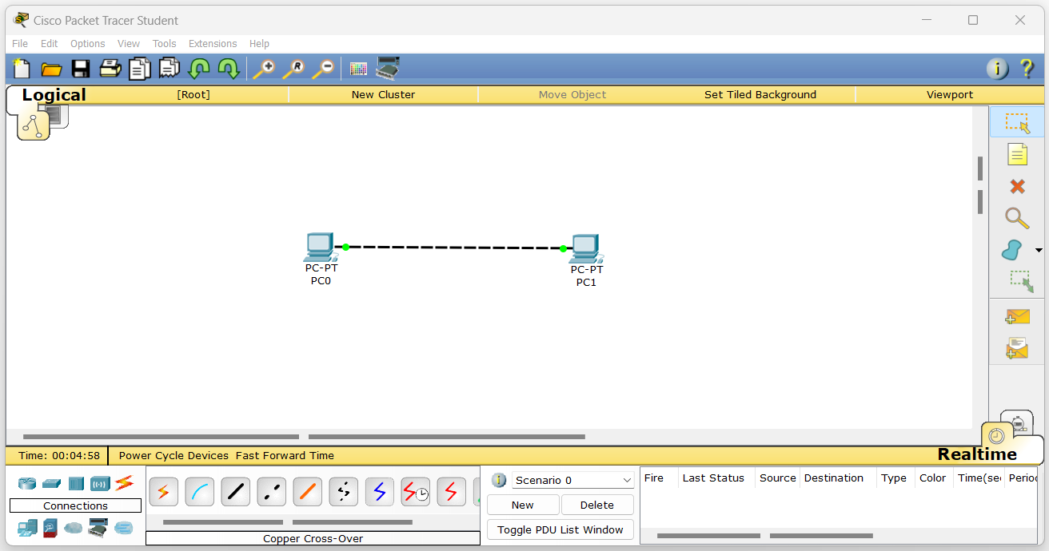

**2)Set IP addresses of both Pc’s.**

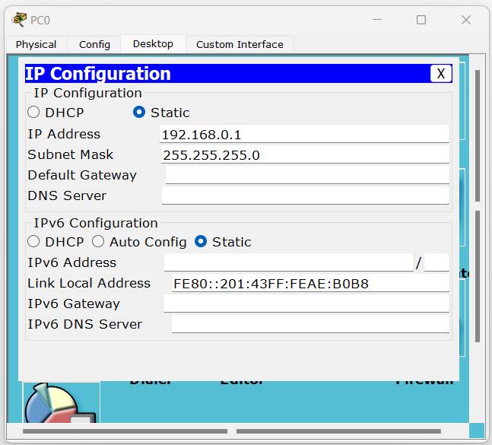

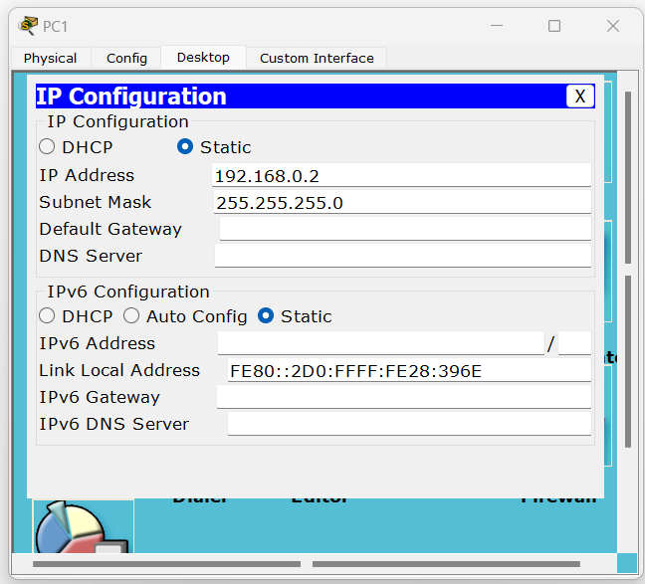

**3)Check connection using Ping command.**

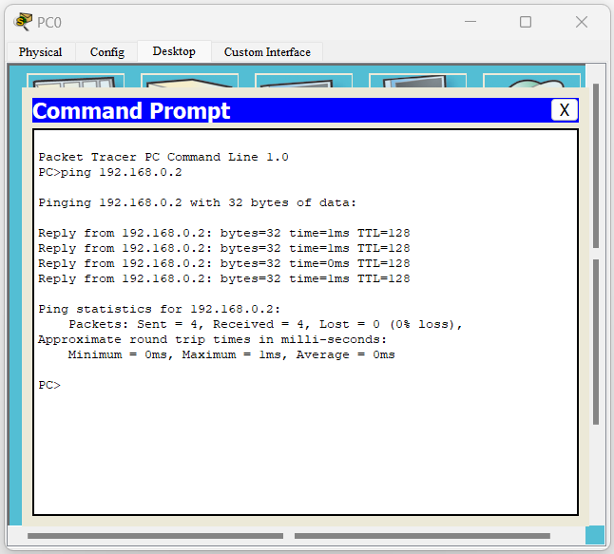

**Practical No. 5**

**Aim: Using Packet Tracer, connect multiple (min.6) computers using layer 2 switch.**

**1)Connecting 6 Pc’s to 2 switches using copper cross-over and copper straight-through wire.**

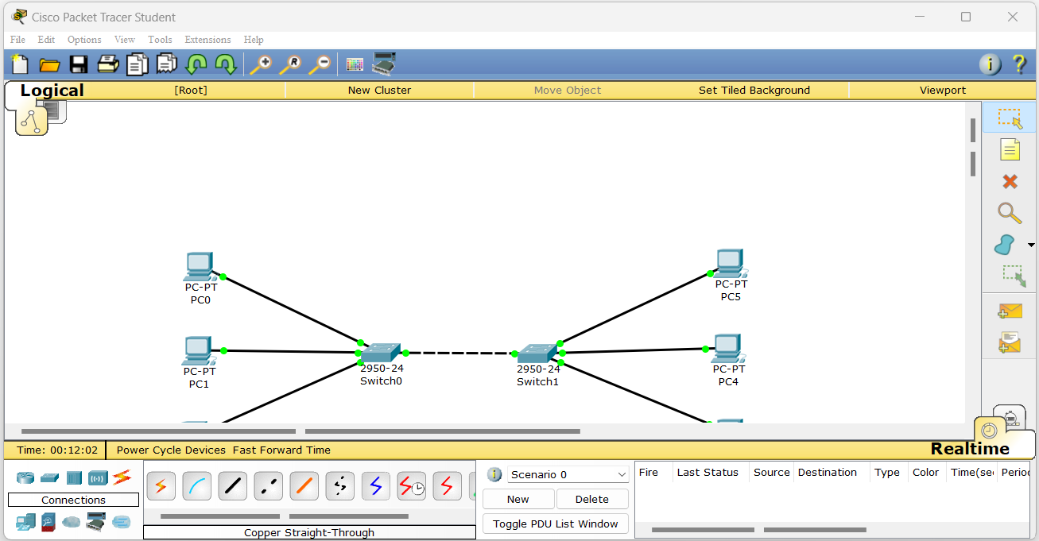

**2)Set IP addresses of all Pc’s.**

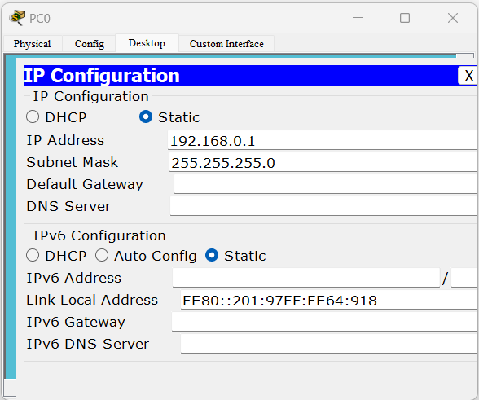

**=**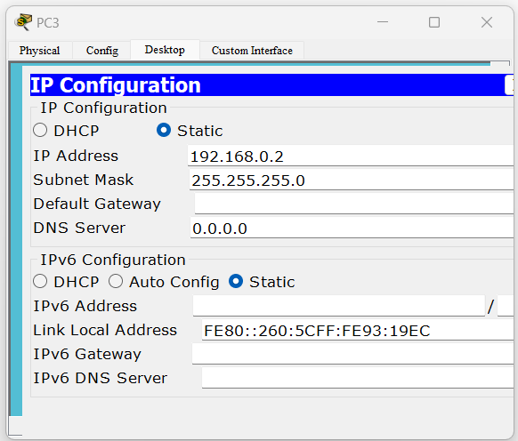

**3)Check connection using Ping command.**

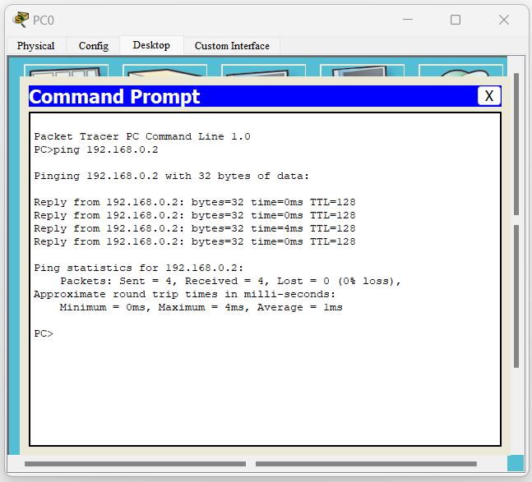

**Practical No. 6**

**Aim: Using Packet Tracer, connect a network in triangular shape with three switch and every switch will have four computer.**

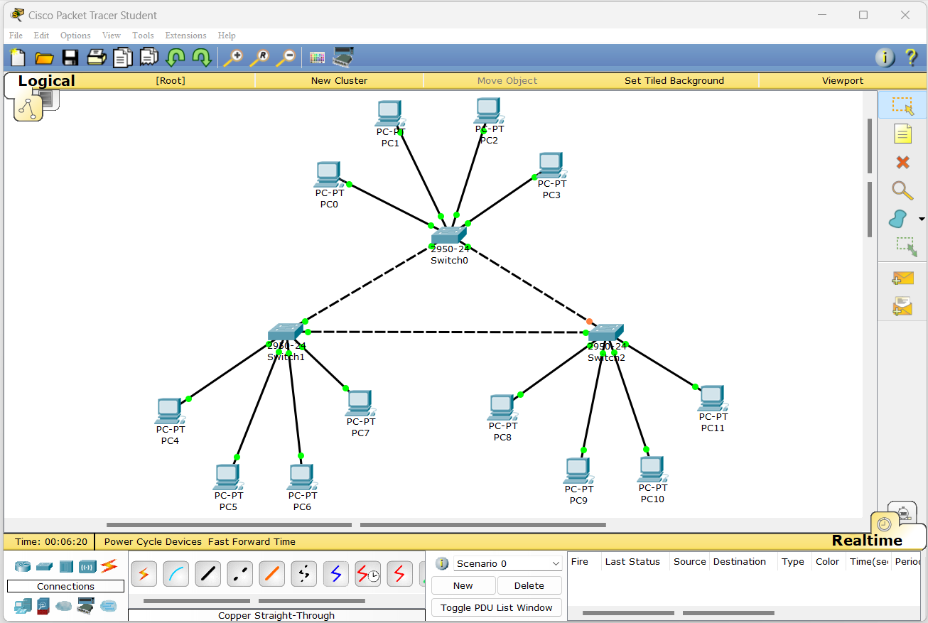

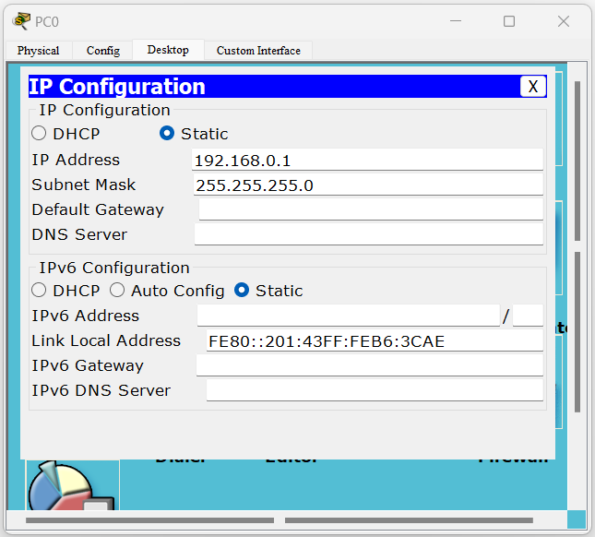

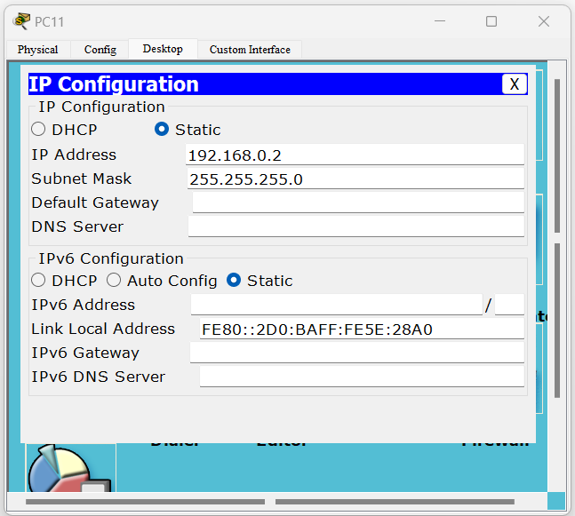

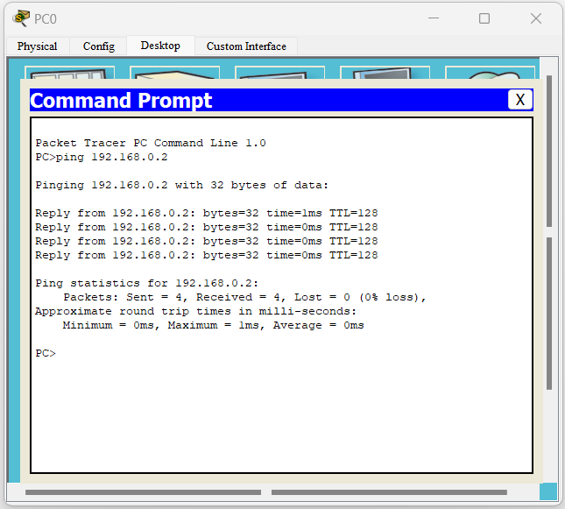

**Practical No. 7**

**Aim: Using Packet Tracer, create a wireless network of multiple PCs using appropriate access point.**

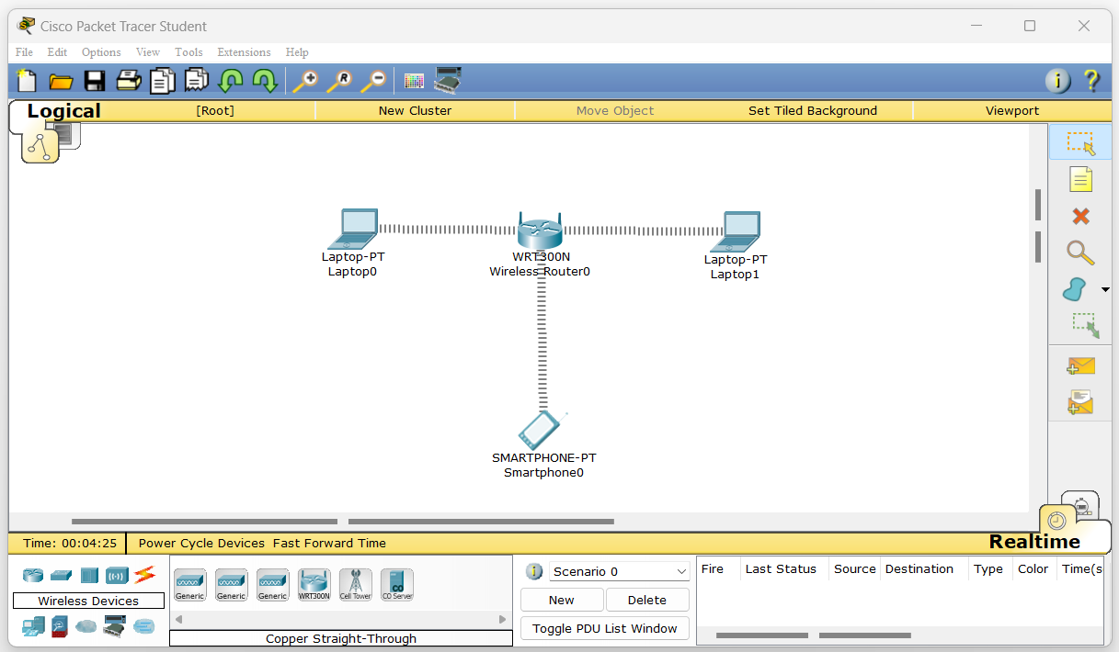

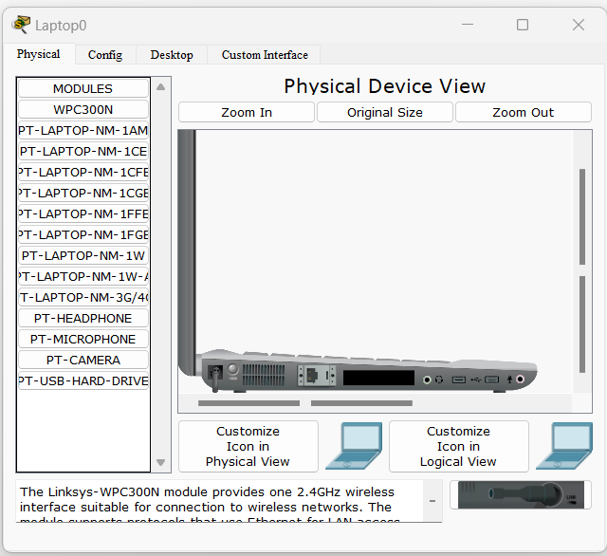

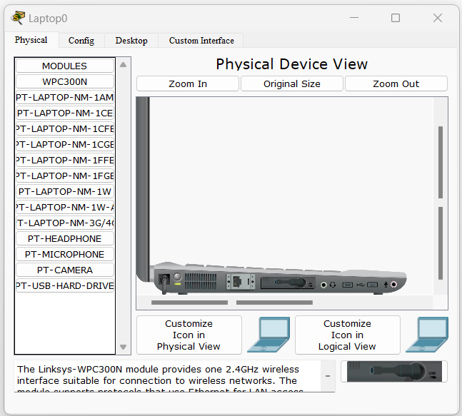

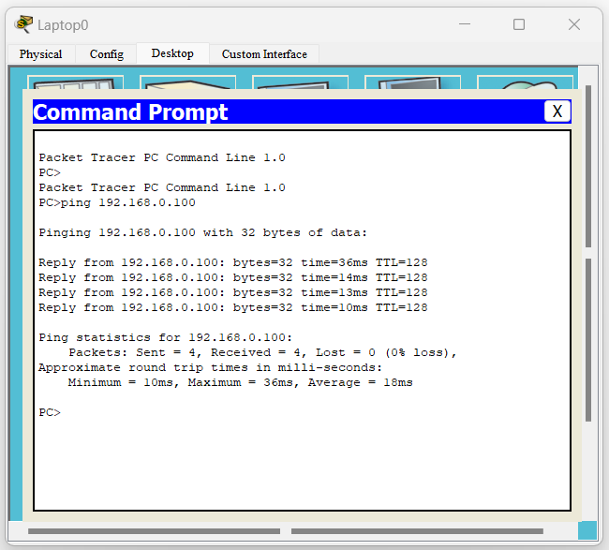

**Practical No. 8**

**Aim: Using Wireshark, network Analyzer, set the filter for ICMP, TCP, HTTP, UDP, FTP and perform respective protocol transactions to show/prove that the network Analyzer is working.**

**1)ICMP.**

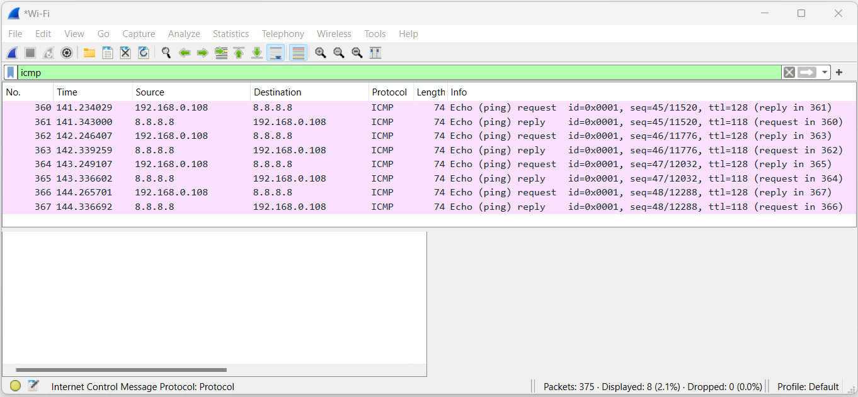

**2)TCP.**

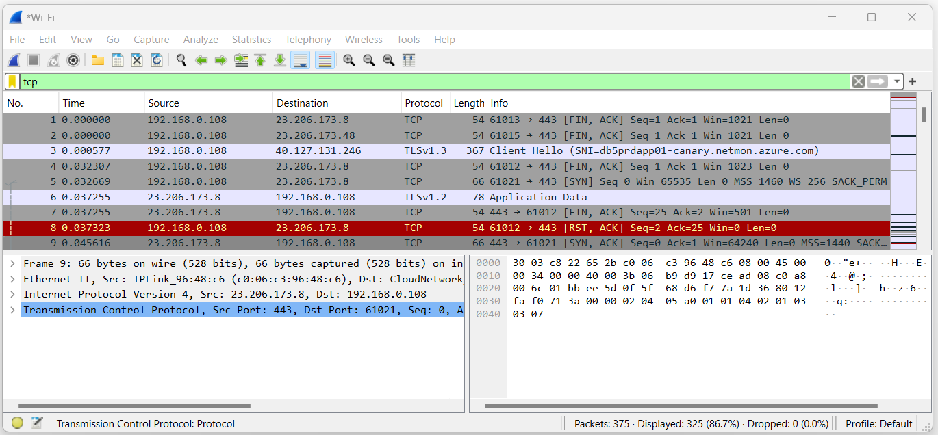

**3)HTTP.**

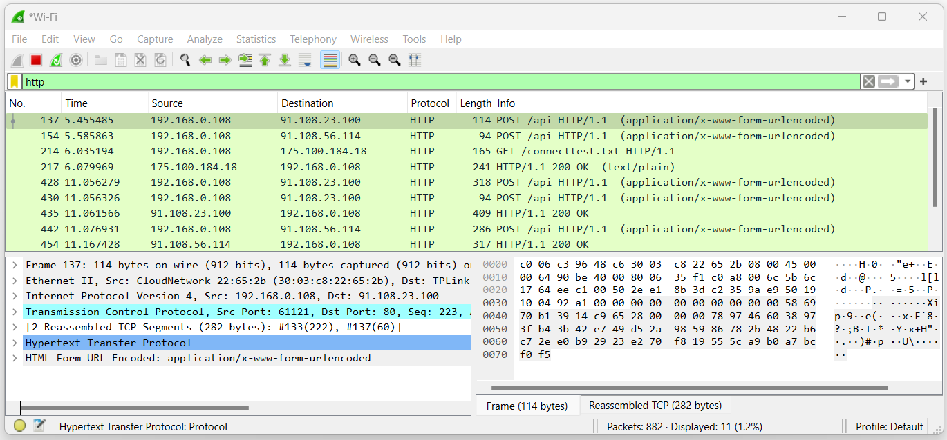

**4)UDP.**

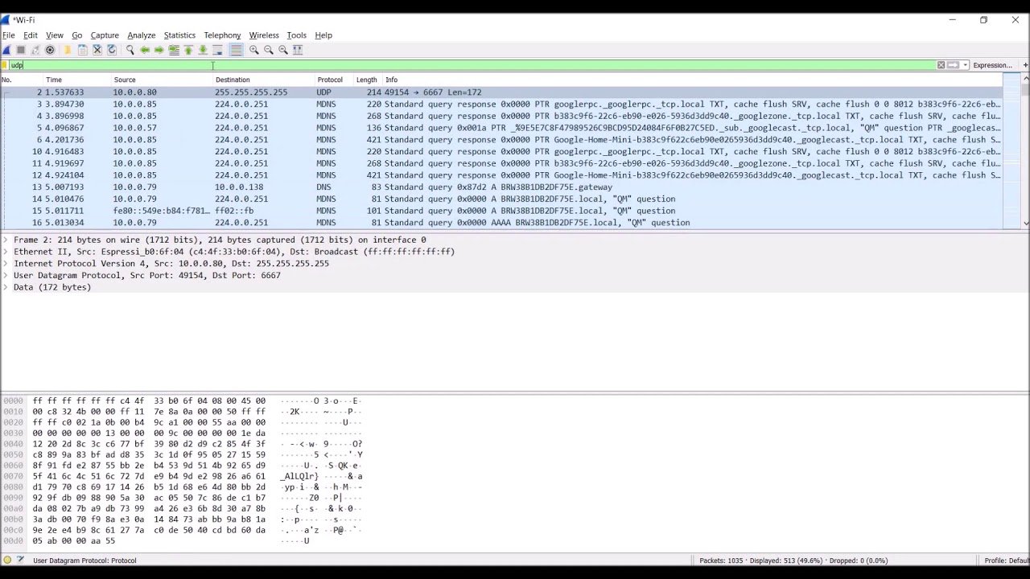

**5)FTP.**

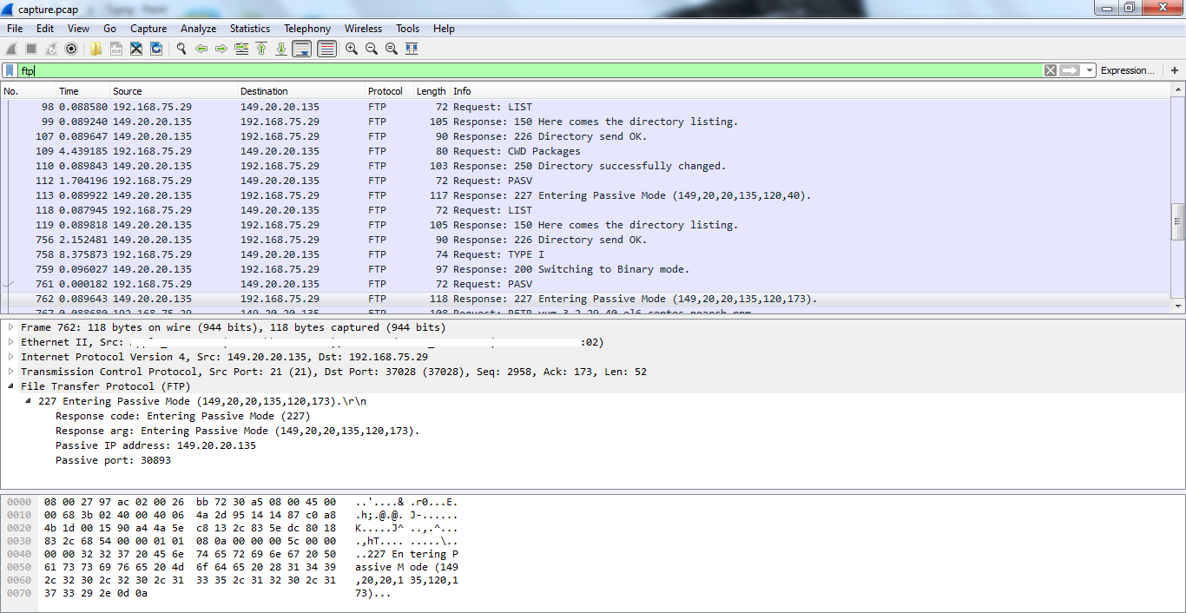

**Click on Statistics and I/O graph then select Time on day and log scale options**

